**How to Write an Article for FCE Writing Part 2**

An article is a very common type of text nowadays. We can find all kinds of articles in newspapers, magazines, blogs, etc. For this reason, in order to know **how to write an article for FCE**, we must bear in mind who will be reading our article. This, as we will see later on, we will find out from the instructions the FCE Writing paper provides us with. But before we move on to that, let’s take a look at the **characteristics of an article for FCE Writing Part 2:**

* **Purpose of an article:**The aim of an article is usually to talk about a topic that we like or that we are familiar with. Besides, **one of the features that articles** have as opposed to other **FCE Writing tasks** is that **an article must entertain the reader** and, almos always, recommend the thing we are talking about.
* **Language:** In general, an article is more informal than an essay, although it will depend on where it is supposed to be published (an international magazine, a teenage magazine, a college magazine, an online blog, a newspaper, etc.). However, the most common case is that we must write a **text in an informal or colloquial style**. For this reason, our tone must be relaxed, making use of contractions, phrasal verbs and other colloquial expressions. Besides, it is recommended to use rhetorical questions and exclamation marks to engage the reader. You should also address the reader directly in the second person (*you*, *your*) and can make jokes if you think they are appropriate.
* **Structure:** Articles must **always have a title**. If possible, this must be catchy and witty so as to engage the reader. Then, each paragraph must address a single idea, to which you must add the introdduction and the conclusion, where you are usually expected to make a recommendation. It is also a good idea to end your article with a rhetorical question, especially if it is going to be an online article where people could (in theory) leave a comment.
* **Giving your opinion:** An article is almost exclusively about giving your opinion, so feel free to do so throught the whole piece of writing. As you are normally asked to write about something you like or enjoy, opinions are expected to be generally positive. Any **article for FCE** is usually a very personal piece of writing, so you can speak in the first person as much as you like.
* **Common topics:**You may be asked to write articles on a variety of topics: the Internet, health and fitness, music, plays, hobbies, etc.
* **Number of words:**you are expected to **write your article in 140 – 190 words**, no more or less than any other type of FCE Writing task.

**FCE Writing Article Example**

Now that we are familiar with the **characteristics of an article**, the best weay to know **how to write an article for FCE Writing** is to take a look at an **example of an article at First-B2 level**. So let’s see an example of a task and a sample answer to that very same task.

**Instructions of an Article for the FCE Writing Paper**

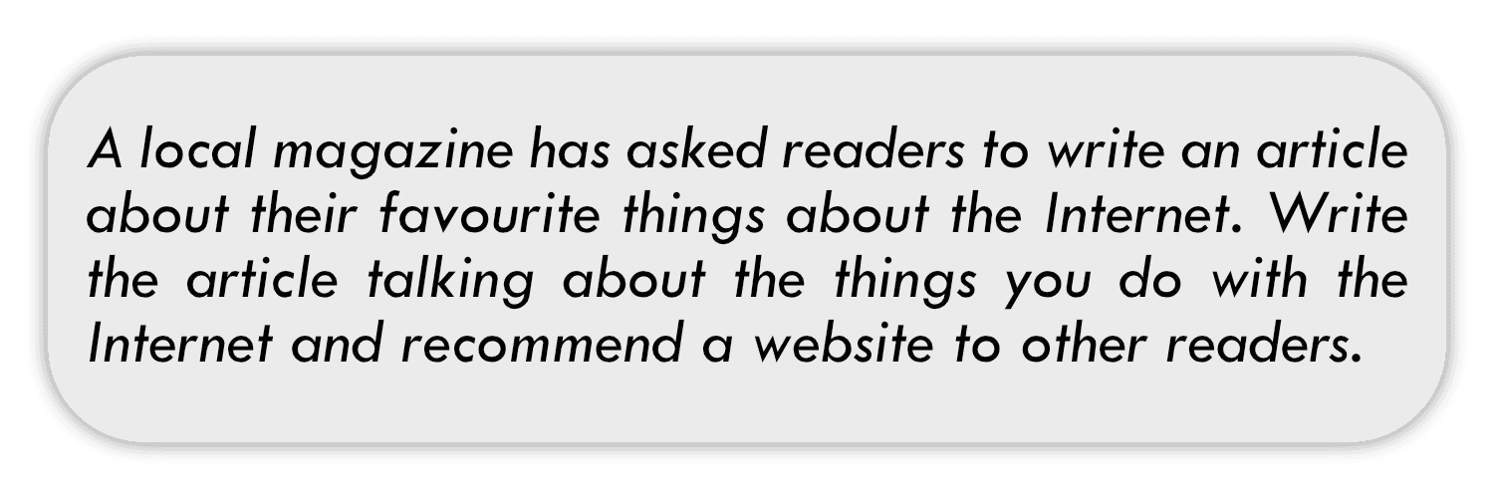It is extremely important to **read the instructions carefully**, as you are supposed to obtain all the information you need to write the article. In this case we can see the following:

* **Where our article will be published:** *a local magazine*
* **Topic:** *their favourite things about the Internet*
* **Main ideas:** *things you do with the internet, recommend a website*

And that’s exactly how we will organise our article, knowing exactly what to talk about in each paragraph.

**Sample answer**

Now that we have an **example of an article task for FCE**, let’s take a look at a **sample article**which answers the task above. Pay attention to the language as well as to the structure marked in red.

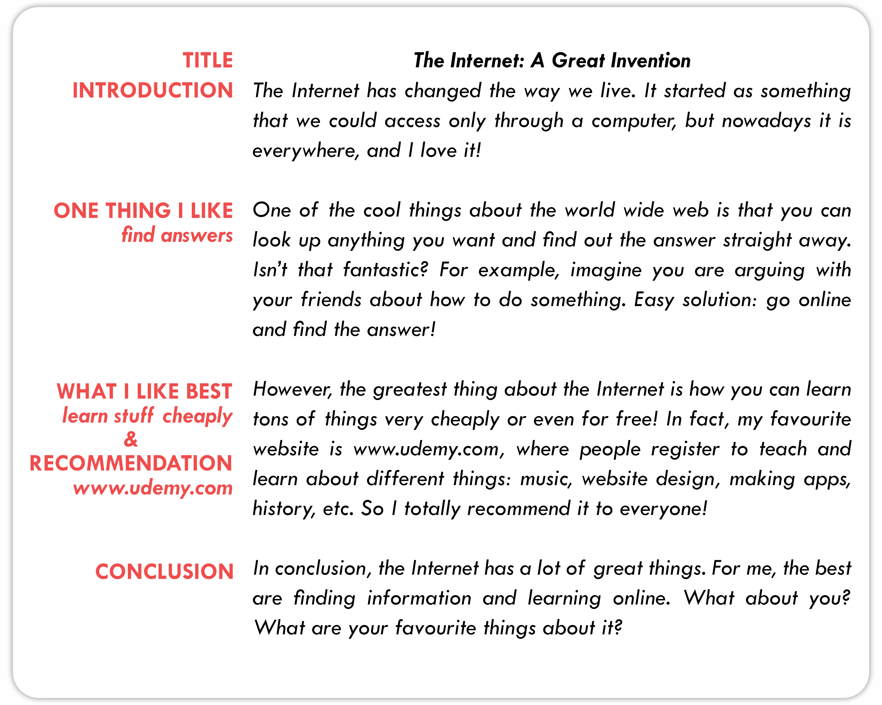

If we take a close look at this **sample article for FCE**, we can see the following features:

* **It is visually appealing**: The structure is clear, leaving space between paragraphs and defining a clear introduction and conclusion.
* **Each paragraph has a clear objective**, as my comments in red indicate.
  + **The introduction** presents the topic in a general way, but making clear what article is about: the Internet.
  + **The second paragraph** talks about why I like the Internet and one of the things that I like about it.
  + **The third paragraph**makes a recommendation of a website, explaining why I like it so much.
  + **The conclusion** is a summary of sorts and asks the reader for some feedback on their own preferences regarding the use of the Internet.
* **The language is informal**:
  + **Phrasal verbs**: *put you up, check out.*
  + **Contractions:** *Isn’t that fantastic?*
  + **Colloquial phrases**: *one of the cool things, I totally recommend it, etc.*
  + **We address the reader directly**: *What about you?*
  + **Exclamation marks:** …*find the answer!*

In this **example of article for FCE Writing** we can appreciate many of the typical characteristics of this type of activity. However, bear in mind that I have tried to simulate a strong B2 level without necessarily reaching C1.

**Useful Expressions to Write an Article for FCE Writing**

If you want to know **how to write an article for FCE**, it is very important to have a repository of useful expressions ready to use. So here are some which can come in handy:

* **Rhetorical questions:**
  + *Have you ever…?*
  + *Do you ever wonder…?*
  + *What do you think about…?*
  + *Are you a… like me?*
  + *Are you one of those people who…?*
  + *What would you say if I told you that…?*
* **Introducing new ideas:**
  + *Firstly,*
  + *First,*
  + *In the rst place,*
  + *To begin with,*
  + *The coolest thing about*
  + *What attracts me most*
  + *One thing to consider is*
  + *Another consideration is*
  + *Secondly,*
  + *As for*
  + *As to*
  + *Also,*
  + *As regards*
  + *In addition,*
  + *In addition to that,*
  + *Moreover,*
* **Concluding the article:**
  + *In conclusion,*
  + *On the whole,*
  + *To sum up,*
  + *To conclude,*
  + *All in all,*
  + *… you will not regret it!*